How to Publish your Private Module Registry for AWS services?

1. Login to Terraform cloud >> select Publish Private Module >>

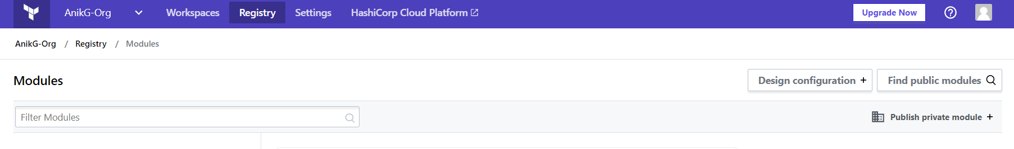

1. Supported VCS provider: <https://www.terraform.io/docs/cloud/vcs/index.html#supported-vcs-providers>



How to create VCS connection? >> <https://www.terraform.io/docs/cloud/vcs/github.html>

1. Create and connect VCS

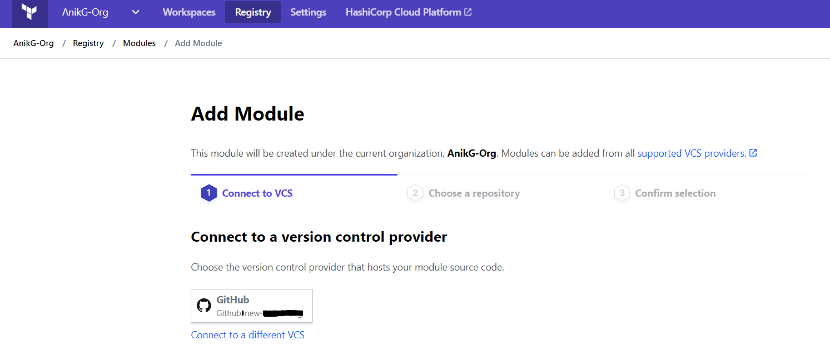

1. Select directory with the format > terraform-<PROVIDER>-<NAME>. & Publish module.

Make sure module has git version tag in place for your module(Mandate).

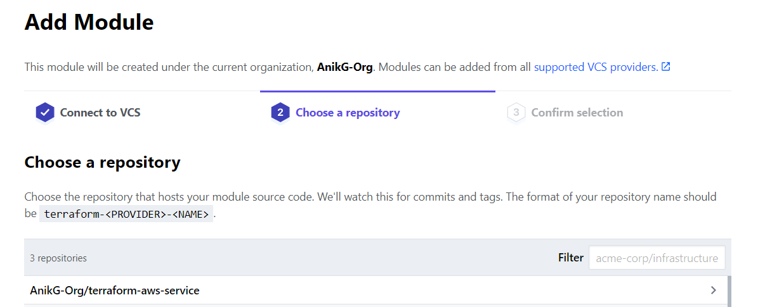

1. Published Module now you can use for Organization with Version control>>

